SCHOOL

Semester One Examination, 2013

Question/Answer Booklet

MATHEMATICS SPECIALIST 3C
SOLUTIONS

Section Two:

Calculator-assumed

Student Number: In figures

In words

Your name

Time allowed for this section
Reading time before commencing work: ten minutes
Working time for this section: one hundred minutes

Materials required/recommended for this section

To be provided by the supervisor
This Question/Answer Booklet
Formula Sheet (retained from Section One)

To be provided by the candidate
Standard items: pens, pencils, pencil sharpener, eraser, correction fluid/tape, ruler, highlighters

Special items: drawing instruments, templates, notes on two unfolded sheets of A4 paper, and up to three calculators satisfying the conditions set by the Curriculum Council for this examination.

Important note to candidates

No other items may be used in this section of the examination. It is your responsibility to ensure that you do not have any unauthorised notes or other items of a non-personal nature in the examination room. If you have any unauthorised material with you, hand it to the supervisor before reading any further.

Structure of this paper

Section | Number of questions available | Number of questions to be answered | Working time (minutes) | Marks available | Percentage of exam
Section One:  Calculator-free | 7 | 7 | 50 | 50 | 33
Section Two:  Calculator-assumed | 12 | 12 | 100 | 100 | 67
 |  |  | Total | 150 | 100

Instructions to candidates

- The rules for the conduct of Western Australian external examinations are detailed in the Year 12 Information Handbook 2013. Sitting this examination implies that you agree to abide by these rules.

- Write your answers in the spaces provided in this Question/Answer Booklet. Spare pages are included at the end of this booklet. They can be used for planning your responses and/or as additional space if required to continue an answer.
- Planning: If you use the spare pages for planning, indicate this clearly at the top of the page.
- Continuing an answer: If you need to use the space to continue an answer, indicate in the original answer space where the answer is continued, i.e. give the page number. Fill in the number of the question(s) that you are continuing to answer at the top of the page.

- Show all your working clearly. Your working should be in sufficient detail to allow your answers to be checked readily and for marks to be awarded for reasoning. Incorrect answers given without supporting reasoning cannot be allocated any marks. For any question or part question worth more than two marks, valid working or justification is required to receive full marks. If you repeat an answer to any question, ensure that you cancel the answer you do not wish to have marked.

- It is recommended that you do not use pencil, except in diagrams.

Section Two: Calculator-assumed (100 Marks)
This section has twelve (12) questions. Answer all questions. Write your answers in the spaces provided.

Working time for this section is 100 minutes.

Question 8 (4 marks)
Determine the derivative of 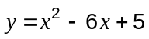 from first principles.

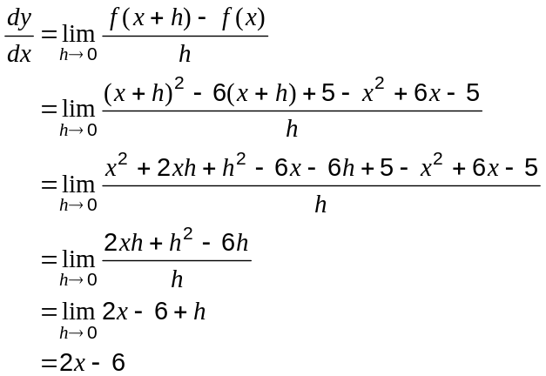

Question 9 (8 marks)
A circle and line intersect as shown.
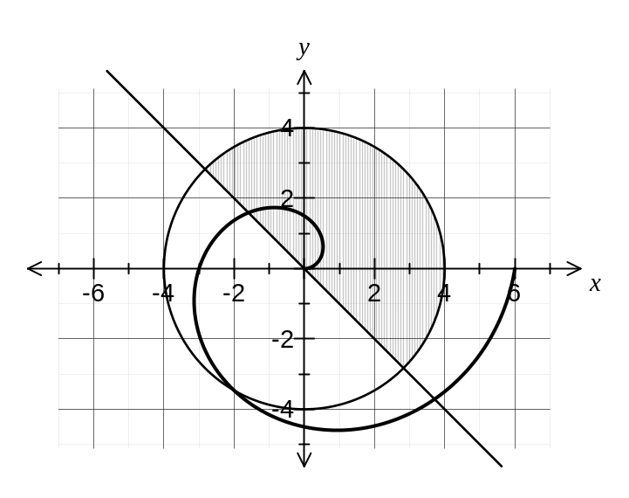
(a) Use polar inequalities to describe the shaded region in the diagram. (2 marks)

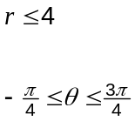

(b) The curve 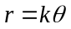, where is a positive constant, passes through the point A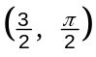.
Add the graph of on the axes above, for 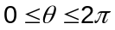. (3 marks)
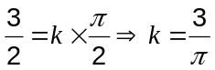

(c) Another point, B, is located at the intersection of the curve with the circle.
Find the distance between points A and B. (3 marks)
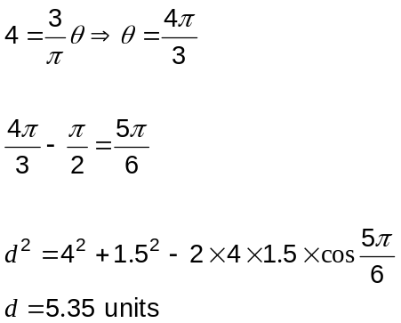

Question 10 (8 marks)
(a) Sketch the following regions in the complex plane.

(i) 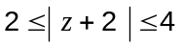 (3 marks)
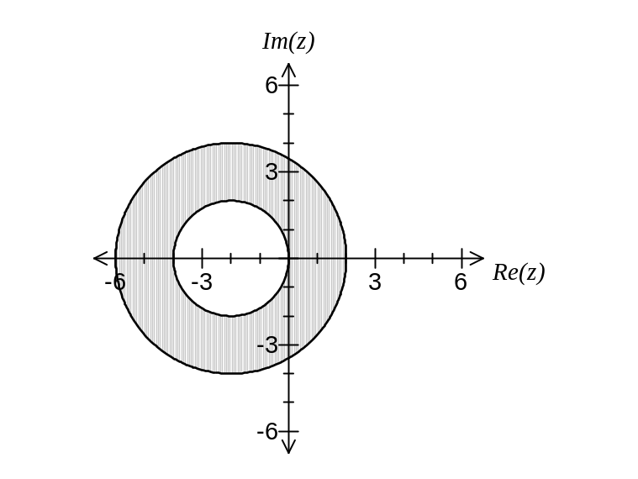

(ii) 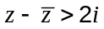 (3 marks)
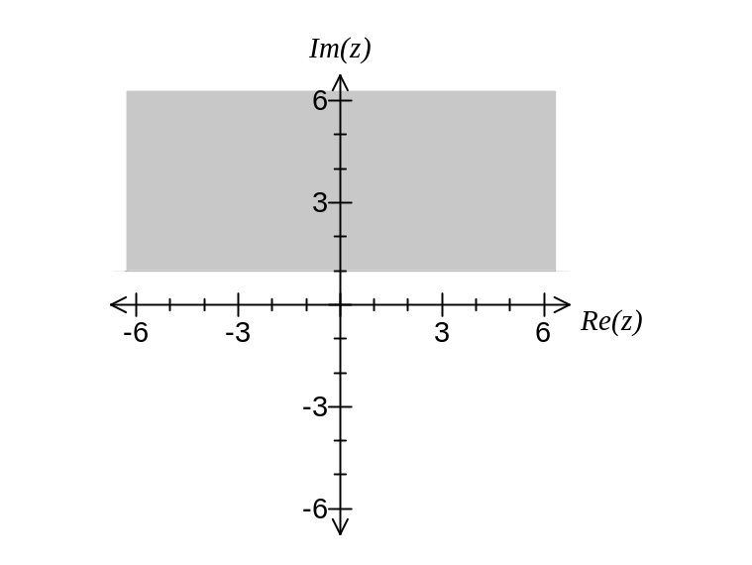

(b) The set of points in the complex plane that satisfy can also be described by 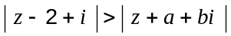, where and are real constants. State the values of and .
(2 marks)
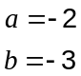
Question 11 (7 marks)
A curve is defined parametrically by 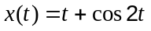 and 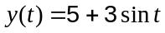 for 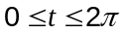 seconds.

(a) Find an expression for the gradient function 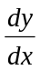. (2 marks)
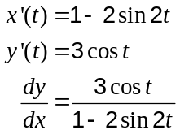

(b) Find the coordinates of all points on the curve where the gradient is zero. (3 marks)
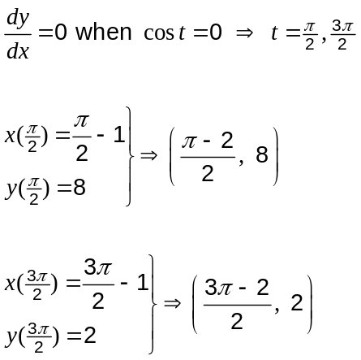

(c) At what time is the tangent to the curve first parallel to the -axis? (2 marks)

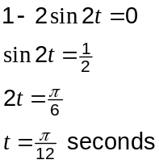

Question 12 (9 marks)
A function is defined as 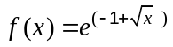 for 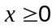.

(a) State the range of . (1 mark)
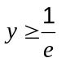

(b) Find 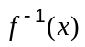. (2 marks)
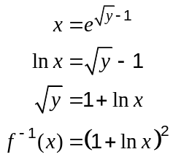

(c) Sketch and on the axes below. (4 marks)
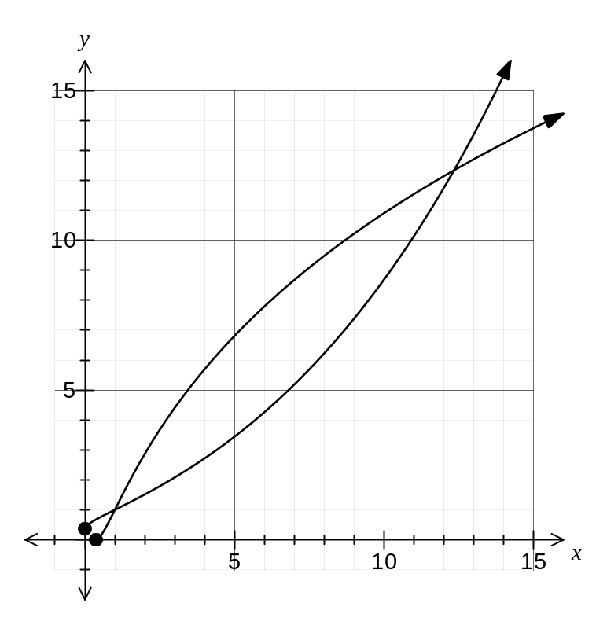

(d) Determine the coordinates of all point(s) of intersection of and to two decimal places. (2 marks)
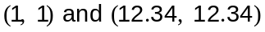

Question 13 (7 marks)
The graph of the function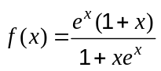 is shown.
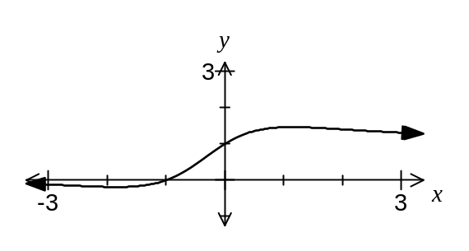

(a) Determine the equation of the tangent to where the function cuts the -axis.
(2 marks)

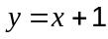

(b) Find, in simplest form, the exact value of 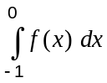, using the substitution 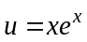.
(5 marks)
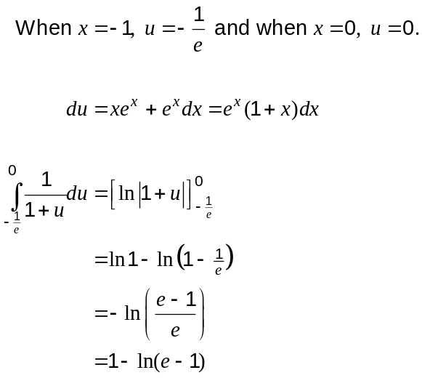

Question 14 (8 marks)
(a) Prove by contradiction that if is a natural number, then 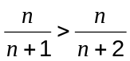. (3 marks)

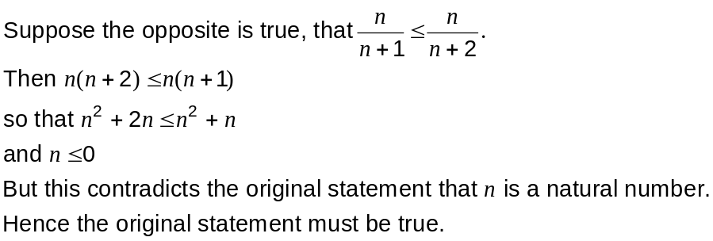

(b) Let 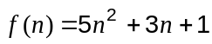, where is an integer.

(i) Examine 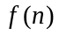 and make a conjecture about the parity of . (1 mark)

..., -27, -9, 9, 27, 55, 93, 141, 191, ...

is always odd.

(ii) Prove your conjecture. (4 marks)
Consider case when is odd and then case when is even:

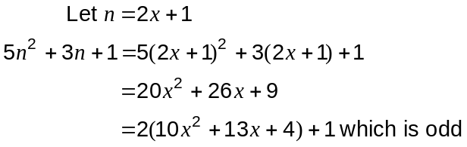

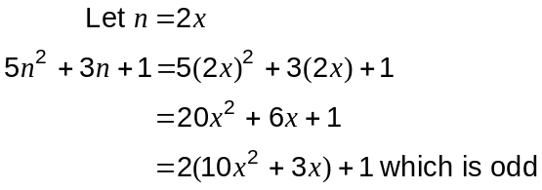

Hence 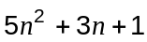 is always odd.

Question 15 (11 marks)
A is the plane with equation 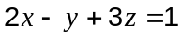.

(a) Find the equation of the line that is perpendicular to A and passes through (-3, 6, 2). Give your answer in parametric form. (3 marks)

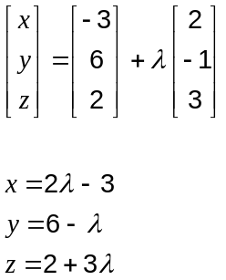

(b) Find the point of intersection of the line in part (a) and the plane A. (3 marks)
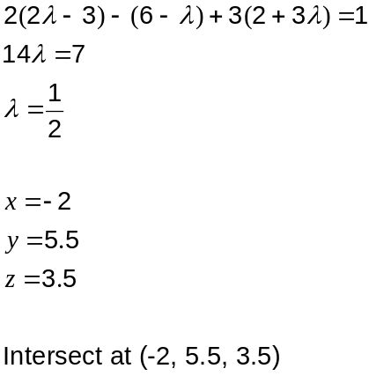

(c) Give an equation for the plane that contains (15, 11, -5) and is parallel to A. (2 marks)

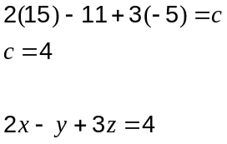

(d) Calculate the size of the acute angle between A and the line 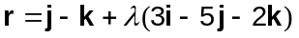.
(3 marks)
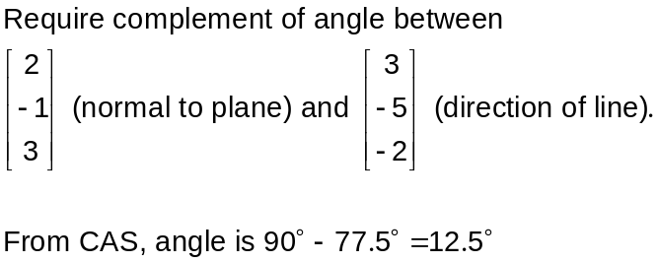

Question 16 (11 marks)
In the parallelogram 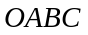, where 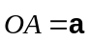 and 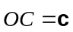, point 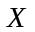 divides 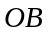 internally in the ratio 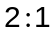 and point 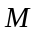 is the midpoint of 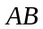.

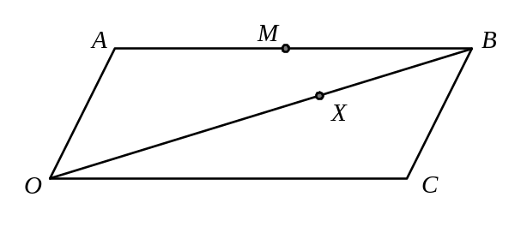

(a) Show that 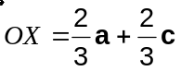 (1 mark)
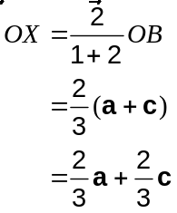

(b) Find 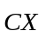 in terms of a and c. (2 marks)

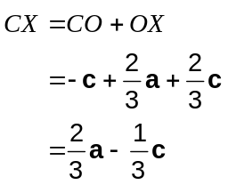

(c) Use vector methods to prove that points , and are collinear. (3 marks)
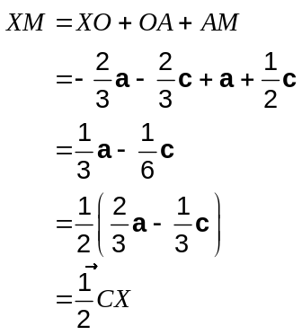
Hence the points , and are collinear since 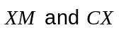
are parallel and both have point in common.

(d) If 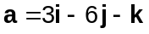 and 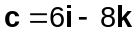, find the area of triangle 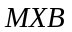. (5 marks)

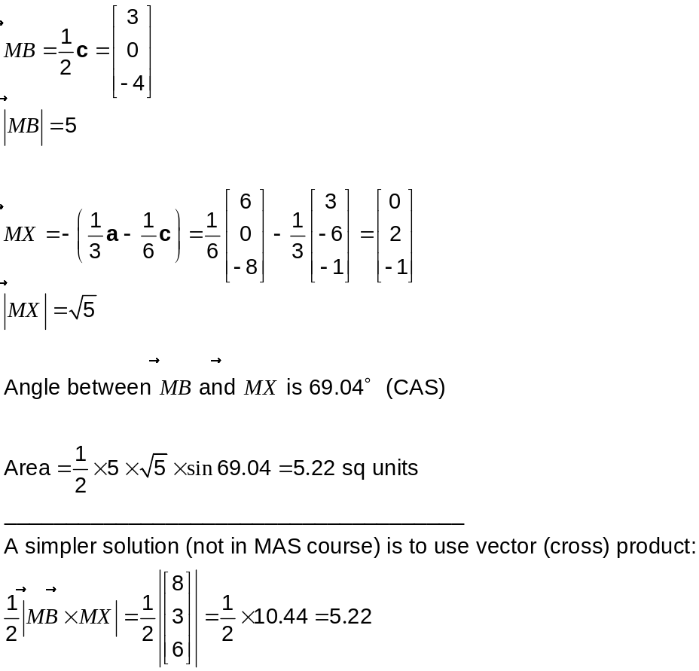

Question 17 (10 marks)
Initially a large tank contains 1 000 litres of pure water. Each minute thereafter, five litres of an alcohol-water mix is added, and five litres of the mixture in the tank is drained. The alcohol-water mix being added is 80 percent alcohol. Throughout this process, the mixture in the tank is thoroughly and uniformly mixed.

Let be the number of minutes since alcohol was first added to the tank and be the litres of pure alcohol in the tank at time .

(a) How much pure alcohol is added to the tank every minute? (1 mark)

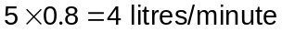

(b) Explain why 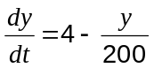 litres per minute. (2 marks)

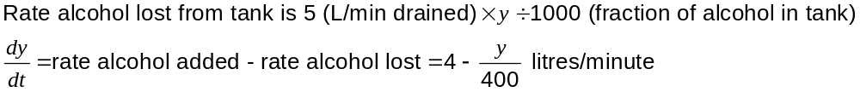

(c) Express as a function of . (5 marks)

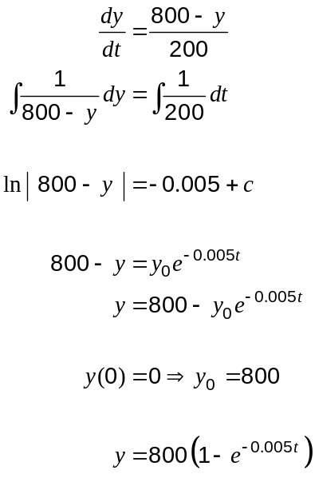

(d) How long, to the nearest minute, until the tank contains 50% alcohol? (2 marks)

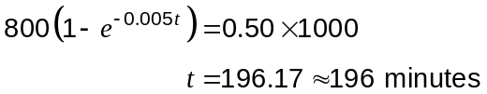

Question 18 (7 marks)
Let the vector 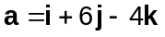 and the vector 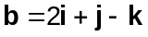.

(a) Determine, in exact form, a unit vector parallel to 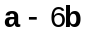. (2 marks)

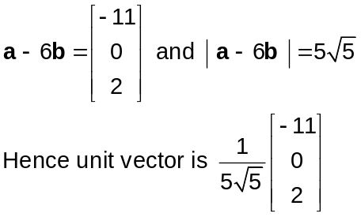

(b) Resolve a into two vector components, one that is parallel to b and one that is perpendicular to b. (5 marks)

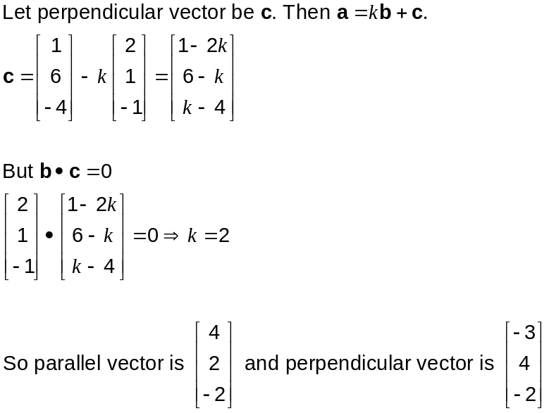

Question 19 (10 marks)
The functions 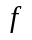 and are defined for 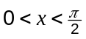 by 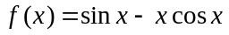 and 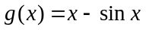.

(a) Over the given domain,

(i) Show that 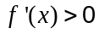. (2 marks)

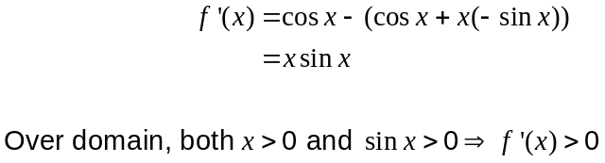

(ii) Hence explain why 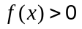. (1 mark)

Since , then is an increasing function and as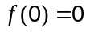 then .

(b) Over the given domain,

(i) Show that 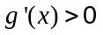. (2 marks)

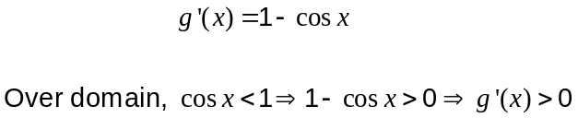

(ii) Hence explain why 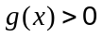. (1 mark)

Since , then 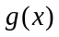 is an increasing function and as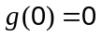 then .

(c) Over the given domain, use your results from (a) and (b) to deduce that

(i) 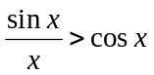. (1 mark)
From (a)

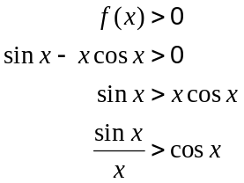

(ii) 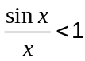. (1 mark)
From (b)

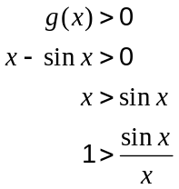

(d) Use your results from (c) to show that 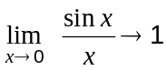. (2 marks)

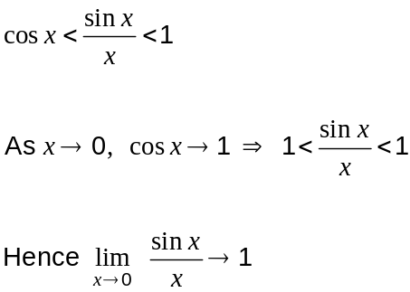

Additional working space

Question number: _________

Additional working space

Question number: _________

This examination paper may be freely copied, or communicated on an intranet, for non-commercial purposes within educational institutes that have purchased the paper from WA Examination Papers provided that WA Examination Papers is acknowledged as the copyright owner. Teachers within purchasing schools may change the paper provided that WA Examination Paper's moral rights are not infringed.

Copying or communication for any other purposes can only be done within the terms of the Copyright Act or with prior written permission of WA Examination papers.

Published by WA Examination Papers
PO Box 445 Claremont WA 6910

